**Chapter 1**

**Introduction**

Human Resource Information System (HRIS) is a system designed to supply information required for effective management of an organization.

Any organization is managed by taking various decisions at the various levels of the management hierarchy. Information is needed to take these decisions. Quality of decisions largely depends upon the nature and type of information provided for taking the decisions. Therefore, designing of an effective information system is vital for the efficient working of an organization. It can be build around electronic computers in case of big organizations like college.

This project ‘Human Resource Information System’ is designed to supply information required for effective management of human resources in an organization. It is designed to monitor, control and influence the movement of people from the time they join the organization till the time they separate from the organization.

**1.1. OBJECTIVES OF HRIS**

* Enhancement:

The main objective of Human Resource Management System is to enhance and upgrade the existing system by increasing its efficiency and effectiveness. The software improves the working methods by replacing the existing manual system with the computer-based system.

* Automation:

The Human Resource Management System automates each and every activity of the manual system and increases its throughput. Thus the response time of the system is very less and it works very fast.

* Accuracy:

The Human Resource Management System provides the uses a quick response with very accurate information regarding the users etc. Any details or system in an accurate manner, as and when required.

* User-Friendly:

The software Human Resource Management System has a very user-friendly interface. Thus the users will feel very easy to work on it. The software provides accuracy along with a pleasant interface, thus making the present manual system more interactive, speedy and user friendly.

* Availability:

The transaction reports of the system can be retried as and when required. Thus, there is no delay in the availability of any information, whatever needed, can be captured very quickly and easily.

**1.2. USERS OF HRIS**

There are three main users of the system. The different users and their respective requirements are as follows:

1. **Visitors**

* To know about the various jobs available in the organization.
* To apply for a vacant job, by sending in their resumes.
* To make any kind of inquiries regarding the organization via email.

1. **Administrators**

* To store and maintain employee information in an organized manner.
* To keep record of the employee absenteeism and turnover rate in different departments.
* To advertise vacancies to attract large number of applications online.
* To automate the process of performance appraisal to avoid any errors.
* To keep a record of the staff attendance and time table.
* To have an automated job evaluation system to determine job requirements.
* To analyze performance of employees to make decisions regarding transfers, promotions, payroll etc.

1. **Students**

* To add his/her views about the organization.
* To fill in the feedback for the staff, which provides them a chance to voice their views.
* To view some basic information regarding the staff.

**1.3. HRIS MODULES**

**1.3.1. RECRUITMENT MODULE**

This module includes information about the vacancies (if any), in the different departments of the organization and also the job requirements for the different jobs.

This module includes the following functionalities:

* Advertisement generator: includes a text-to-html generating system which automatically creates an html advertisement to be displayed on the website when the information regarding the vacancy is provided as textual input to it.
* Application System: allows the visitors of the website to apply for various jobs under the vacancies tab, and attach their resumes along with filling the application forms.
* Selection System: checks the details provided by the job applicant against the job requirements and if the two match, then the application is visible to the administrator under the ‘applicants’ section and the administrator can invite them for interview via email.
* Job Information: includes the information regarding job description and job requirements for the various jobs in the organization.

**1.3.2. PERFORMANCE APPRAISAL MODULE**

This module includes information about performance of the employees working in different departments. This information serves as the input to compute increments, transfer, promotion, succession planning, career planning etc. for the employees.

This module includes the following functionalities:

* Feedback forms: includes a web-based interface for collecting the feedback data from the students and professors.
* Feedback Analysis: includes an intelligent automated analysis system which analyses the data collected through feedback forms and generates pie-charts, histograms, etc. based on the results of analysis.

**1.3.3. MAINTENANCE MODULE**

This module is designed to contain information about the welfare services provided to the employees by the organization.

This module includes the following functionalities:

* It analyzes the services provided by the organization against the set standards and determines the areas for improvement.
* It provides a clear view of benefits and services offered to employees.

**1.3.4. PAYROLL MODULE**

This module contains information concerning wages, salaries, wage incentives, allowances, prerequisites or fringe benefits, deductions etc.

This module contains the following functionality:

* Based upon the salary and performance of each employee, the incentives, bonus and deductions etc. can be automatically determined.

**3.2.5. PERSONNEL ADMINISTRATION MODULE**

This module includes personal records of each employee working in the organization as regards leaves, transfer, promotion, increments, etc.

This module includes the following functionalities:

* Stores updated information of the individual employees including designation, salary, educational qualification, subject specialization, performance charts, career paths, etc.
* Keeps track of the time tables of the employees.
* Keep track of the leaves taken by the employee and then calculate the employee absenteeism using this information.
* Keep track of employee attendance. This information is provided as one of the input in employee’s performance appraisal.

**3.2.6. MANPOWER PLANNING MODULE**

This module includes information that could assist human resource mobilization, succession planning and career planning.

This module includes the following functionalities:

* It forecasts demand for key jobs as well as employee turnover and patterns of inter-organization mobility.
* It predicts future employee and competency needs for staffing and development activities.

**3.2.7. PERSONNEL RESEARCH MODULE**

This module contains historic and current data about employee’s attitude, absenteeism, turnover, etc. which may be used for different types of analysis.

This module includes the following functionalities:

* It computes the employee turnover rate in different departments.
* It computes employee absenteeism rate in different departments.

This information can be used for different types of analysis regarding the organization such as employee satisfaction etc.

**1.4. SYSTEM REQUIREMENTS**

**1.4.1. SOTWARE REQUIREMENTS**

* Programming Languages: php, html, Ajax
* Supporting Libraries: jQuery
* Database: phpMyAdmin
* Tools: Notepad++, Wamp server 2.2, Google Chrome Browser.
* Operating System: Windows XP or above.

` **1.4.2. HARDWARE REQUIREMENTS**

|  |  |  |
| --- | --- | --- |
| **H/W COMPONENT** | **MINIMUM** | **RECOMMENDATION** |
| Processor | 133MHz | 500MHz |
| RAM | 32 MB | 128 MB |
| Free Hard Disk Space | 30 MB | 50 MB |
| Monitor | VGA | SVGA |

**1.4.3. INTERNET SPEED REQUIRED**

* Minimum 56kbps for MODEM connection.
* Minimum 256kbps for BROADBAND connection.

**Chapter 2**

**Literature review**

HRM (human resource management) is especially important in a knowledge-based economy, where ideas and expertise are greatly valued, and a creative and innovative workforce is necessary to meet the challenges of this new economy. Efficient and effective management of human capital is increasingly an imperative and complex process. As a result, there has been a considerable increase in the number of organizations gathering, storing, and analyzing information regarding their HRs through the use of a software which is HRIS (human resource information system). The growing importance of HRIS is due to the recognition of HR practitioners that IT (information technology) and IS (information system) should be a part of HR functions mainly to develop and use better HRM programmes. This adoption of HRIS by organizations combined with the increasing sophistication of this software, presents the HR function with new challenges which demands the HR professionals to participate and contribute fully to their companies, as true strategic business partners.

Leading management thinkers suggested that, “It is not technology, but the art of human and humane management” that is continuing challenge for executives in the 21st century (Drucker, Dyson, Handy, Saffo, & Senge, 1997). Similarly, Smith and Kelly (1997) believed that future economic and strategic advantage will rest with the organizations that can most effectively attract, develop, and retain diverse group of the best and the brightest human talent in the market place. Many HR (human resource) executives and managers are so busy taking care of their daily duties, which are generally administrative, that they neglect to consider important issues that are coming down the road. This is a trap that any department can fall into, but it can be especially devastating for HR, which must battle decades of preconceived notions about the department’s ability to contribute to corporate planning. Thus, today with an increase in the number of organizations, HR is now viewed as a source of competitive advantage (Michael et al., 2012). It is necessary for firms to have highly skilled human capital to provide them with a competitive edge. So, an effective management of HR in a firm is to gain advantage in the marketplace which requires timely and accurate information on current employees and potential employees in the labor market. With the changing world and evolution of new technology, meeting this information requirement becomes important. HR managers need to be aware that the change in technology will not only increase the quality of employee information, but also will have a strong effect on the overall effectiveness of the organization. To reduce the routine transaction and traditional HR activities and to deal with the complex transformational ones, the organizations began to electronically automate many of these processes by introducing specialized HRIS (human resource information system) or HRMS (human resource management system). HRIS refers to the systems and processes at the intersection between HRM (human resource management) and information technology. It is a system used to acquire, store, manipulate, analyze, retrieve, and distribute information regarding an organizations human resource. An integrated HRIS is a database shared by all HR functions that provide common language and integrates all HR services.

HRIS has increasingly transformed since it was first introduced at General Electric in the 1950s. HRIS has gone from a basic process to convert manual information-keeping systems into computerized systems. Because of the complexity and data intensiveness of the HRM function, it is one of the last management functions to be targeted for automation (Bussler & Davis, 2001/2002). This fact does not mean that HRIS is not important, it just indicates the difficulty of developing and implementing it compared with other business functions (e.g., billing and accounting system). Powered by information system and Internet, almost every process in the every function of HRM has been computerized today. Currently, HRMS encompass:

* Payroll;
* Time and attendance;
* Appraisal performance;
* Benefits administration;
* HR management information system;
* Recruiting;
* Performance record;
* Employee self-service;
* Absence management.

The design, selection, and use of HRIS are contestation as a range of meanings that are attached to the technology that either undermine or highlight its perceived value and significance and which impact on the extent to which it is to be used in a strategic or more administrative fashion. Recent debates about technology and organization have highlighted the importance of social context and sought to develop frameworks which acknowledge both the material and social character of technologies including HRIS (Dery, Hall, & Wailes, 2006). Accordingly, theories which can be considered as “social constructivist” can play an important role in the study of technology as they explicitly recognize that technologies, such as HRIS, cannot be evaluated and analyzed without having an explicit understanding of the context of individuals and groups which consequently 832 EFFECTIVENESS OF HUMAN RESOURCE INFORMATION SYSTEM ON HR FUNCTIONS comprehend, interpret, use, and engage with the technology (Grint & Woolgar, 1997; Orlikowski & Barley, 2001; Williams & in the form of stand-alone products and ERP⎯Edge, 1996). Sophisticated HRMS software gives HR departments the ability to effectively and efficiently⎯(enterprise resource planning) systems administer data in areas ranging from benefits to regulatory compliance. Also important, however, is HRMS’s potential to transform HR from a cost center into, if not an outright profit center, a far less expensive department that can also function as a strategic advisor. The existing literature on HRIS suggests that they have different impacts on HR across organizations, but provides little explanation for this variation. It is early suggested that HRIS were used predominantly to automate routine tasks and “to replace filing cabinets” (Martinsons, 1994). HR professionals began to see the possibility of new applications for the computer. The idea was to integrate many of the different HR functions. The result was the third generation of the computerized HRIS, a feature-rich, broad-based, and self-contained HRIS. The third generation took systems far beyond being mere data repositories and created tools with which HR professionals could do much more (Lloyd, Byars, Leslie, & Rue, 2004). It has the potential to assist the HR function in developing business strategy, and thus enhancing organization performance (Barney & Wright, 1998; Broderick & Boudreau, 1992; Gueutal, 2003; Lawler, Levenson, & Boudreau, 2004; Lengnick-Hall & Moritz, 2003). HRIS is used to acquire, store, manipulate, analyze, retrieve, and distribute pertinent information regarding an organization’s human resources (Kavanagh, Gueutal, & Tannenbaum, 1990). It provides HR professionals with the time needed to direct their attention towards more business critical and strategic level tasks, such as leadership development and talent management. HRIS provides an opportunity for HR to play a more strategic role, through their ability to generate metrics which can be used to support strategic decision-making (Lawler & Mohrman, 2003). The current generation of HRIS automates and devolves routine administrative and compliance functions traditionally performed by corporate HR departments and can facilitate the outsourcing of HR. More recent research shows greater use of HRIS in support of strategic decision making by HR. With an appropriate HRIS, HR staff enables employees to do their own benefits updates and address changes, thus freeing HR staff for more strategic functions. Additionally, data necessary for employee management, knowledge development, career growth and development, and equal treatment are facilitated. Finally, managers can access the information they need to legally, ethically, and effectively support the success of their reporting employee.

**HR INFORMATION SYSTEM**- HR Information System is an information system, which is basically used to track data relating to HR. It is one of the Management Information Systems. There has been a lot of change as to how employee data were stored before compared to present systems used in organization. It integrates information like employee details, pay roll, benefits, performance tracking and appraisal etc. Technological advancement led to a lot of changes in HR Management. The storage of data was now shifted from manual ledgers and books to computer hard drives and magnetic tapes. Storage of data became easier and a lot of manual work was removed. HR Management was later seen as a strategic building platform which dealt with the most important resource of any organization. Hence it came to be known as Strategic HR Management (SHRM). The HR Management had total make over when HR Information System was brought into implementation.

**TRADITIONAL VIEW OF HRIS**- HRIS is designed to supply information required for effective management of the organization i.e. for decision making relating to human resource. Human resource departments hold the record of the employees of the organization including personal history, skills and salary etc. The basic level of HRIS is used to help to manage employment relationships within the organization and employees. In previously Companies were used to tracking data on paper and spreadsheets and its take time to manage record properly and its time consuming too.Typical HRIS record employee information, wage and salary data, review dates, benefits, education and training, attendance, performance data,/ appraisal results etc.

**MORDEN VIEWS HRIS**- Leading management thinker suggest that ,”it is not technology, but the art of human and human- management.” That is the continuing challenges for executive in the 21st century. (Drucker ,dyson, Handy, saffo,&Senge 1997). Similarly , Smith and kelly1997 believe that” future economic and strategic advantages will rest with the organization that can most effectively attract , develop and retain a diverse group of the best and the brightest human talent in the Market place. The effective management of the human resource in the firm to gain a competitive advantage in the market place requires timely and accurate information on current employees and potential employees in the labor market. With the evaluation of computer technology ,meeting this information requirement has been greatly enhanced through the creation of HRIS. With technological advancements many companies have realized the need to implement more sophisticated computerized systems, like Human Resource Information Systems. By moving to HRIS, companies are able to keep more accurate and up-to-date records, allowing them to better prepare for future growth in their companies. A computerized HRIS is designed to monitor, control and influence the movement of people from the time they join the organization till the time they leave it. Human resource information systems are built to reduce the manual work of HR expertise. HRIS helps to abandon paper forms or reports because all information is available through the system.

In the early development of human resource management, information systems, although often accurate and comprehensive, were mainly used for administrative and operational purposes. Forms were used to collect leave requests, workers compensation and accident data, and salary variation and superannuation entitlements. During the 1945 and 1960 only manual work is done for manage all HR activities in organization, they have human capital issues, employees morale and formal selection and development method is earlier organization not so much focus on HR related activities they was not taking interest in HR main function . Then early 1960 to 1970 personnel become change into human resource organization was focus on human resource. Human Resource was seen as key in organization. In this time HRIS was used mostly for keeping administrative records.1970s and 1980s, several factors radically changed attitudes towards human resource information systems. After that from 1980 to current large and small business organization are utilizing HRIS. The increasing complexity of payroll systems in this period demanded more flexibility in, and access to information system. Personal computers have made HRIS available and affordable for any sized firm. HRIS has evolved from simple record-keeping to complex analytical tools to assist management decision making. Then according to globalization and technological change computerize HRIS was developed in it system seeks to merge the activities associated with human resource management (HRM) and information technology (IT) into one common database through the use of enterprise resource planning (ERP) software. The goal of HRIS is to merge the different parts of human resources, including payroll, labor productivity, and benefit management into a less capital- intensive system than the mainframes used to manage activities in the past. HRIS also called Human Resource Management System (HRMS).Organizations, centralized payroll processing sections began to be separated from other human resource functions. Some organizations contracted their payroll responsibilities to external payroll bureaus with greater technological expertise, and for reduced costs. now many software use in the organization according to their needs and want.

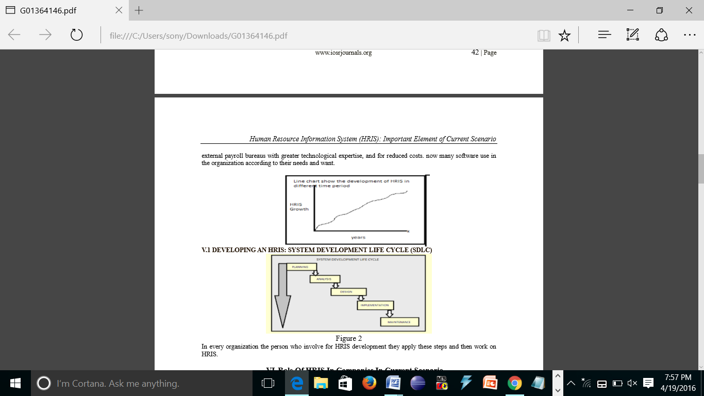

Fig 2.1. Evolution of HRIS

HRIS help a firm maximize the use of human resource and maintain competitiveness in its market. In most large organizations, human resource information systems (HRISs) provide the technology backbone supporting the complete body of human resource (HR) functions. In this role, HRISs play a critical part in the operation of each component of HR. Additionally, by integrating across business processes HRISs provide organizations with control, forecasting, and planning tools that supersede simple computerization of HR functions. For these reasons, effective use of HRISs in organizations contributes to overall organizational effectiveness. Human Resource Information System is a set of people, forms, procedures and data utilized to store, analyze, distribute and use information of human resources. HRIS goal is to provide accurate information for the use of persons making human resource related decisions. The organization can use HRIS for human resource planning. New recruitments can be posted via HRIS as well as applications can be scanned and stored. HRIS also stores information about the employees’ participated trainings and learning sessions. Performance appraisal, compensation, benefits, competences and development plans are easily maintained in HRIS. Employees can search for a new career within the organization and be aware of the future trainings. HRIS allows managers to follow employee’s ́ job performance and planned versus used hours for a certain assignment. HRIS offers various reports available. Typical HR program involve things such as record keeping, recruiting, selection, training, employees retention and compensation.

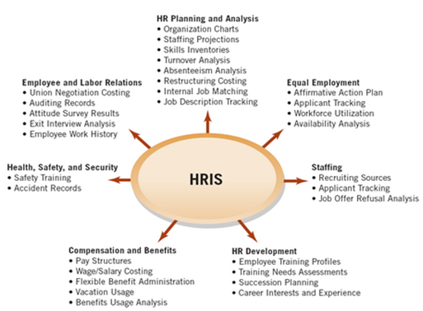

Fig 2.2. Uses of HRIS

An effective HRIS provides information on just about anything the company needs to track and analyze about employees, former employees, and applicants. The company will need to select a Human Resources Information System and customize it to meet according to company needs. Comprehensive and integrated HRIS can be used widely - in administrative, operational and strategic fields by HR and other managers. On the operational level HRIS data can be used to identify potential internal applicants for job vacancies, saying external recruitment costs and assuring employees of career opportunities. HRIS enables the human resource department to make a more active role in organizational planning. Computerization will make forecasting more timely, cost effective, and efficient. With continued technological breakthroughs HRIS systems are becoming increasingly advanced. One of the most core HRIS functions is intranet HR self-service. Some larger companies use their intranet today for online appraisals, career management, sentiment surveys, training registrations and publishing people related company information. An HRIS or HRMS monitored by qualified specialists who know technology and HR functional and tactical processes can manage compliance with federal and state laws, streamline processes for recruitment and selection, and produce analyses, data and reports for internal and external use. Other advantages of an HRIS include the ease of use for qualification computer technology specialists, accuracy of information and the ability to perform HR audits using any combination of parameters. The employee and manager self-service features are excellent ways to free up the time of your human resources staff members for project work and other duties. Employees and managers can locate answers and information quickly without the need to consult an HR representative every time.

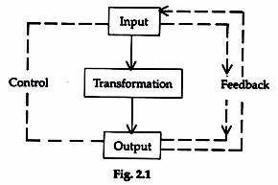

Fig 2.3. HRIS process

With an appropriate HRIS, Human Resources staff enables employees to do their own benefits updates and address changes, thus freeing HR staff for more strategic functions. Additionally, data necessary for employee management, knowledge development, career growth and development, and equal treatment is facilitated.

1. Madhuchanda Mohanty and Santosh Kumar Tripathy (2009)4 analyzed the HRIS of NALCO in their study. The authors exhibit that the use HRIS in NALCO has improved the overall pace and competence of HR functions, but still needs some more developments. The study also states that HRIS cannot be used for analytical purpose but can only be done for administrative purpose.

2. MD. Sadique Shaikh (2012)5 discussed about three models for HRIS designing namely basic HRIS design model, HRIS hexagonal and HRIS phase’s model. The author emphasized on the payback of HRIS designing and execution for all levels and domains of businesses; in the form of profitable strategic HR and related business plans and decision, to forecast and to control HR process inside and outside of business organization using HR-databases or HRKnowledgebase’s, which includes information related to human resource maintained and processed by HRIS.

3. Prof. Dr. Anil C. Bhavsar (2011)6 has discussed about various advantages, applications and importance of HRIS. The study also highlights “today's HRIS has the potential to be an enterprise wide decision support system that helps achieve both strategic and operational objectives”.

4. Kenneth et. al. (2002)7 in his research paper has stressed upon various administrative advantages which may include employee self service, interactive voice response etc. and strategic advantages of HRIS which can be in the course of information gathering, processing, and sharing.

5. Dr. Shikha N. Khera, Ms. Karishma Gulati (2012)8 in their research paper have stressed upon Impact of HRIS on Human Resource Planning and the advantages of HRIS with special reference of IT companies.

Human resources information systems (HRIS) can play an important part in a company’s HR function. After all, we live, work and play in the information age. Implementing an effective HRIS can be sure-fire for HR to stay on the cutting edge in its bid to deliver more effective and streamlined service.

**Chapter 3**

**Work carried out**

**3.1. METHODOLOGY**

Human Resource Information system is the linking mechanism which connects all the decision making centers in an organization. The development of this project will be conducted in following steps:

1. **Planning of system**: Planning of Human Resource Information System requires the identification of objectives of the system. This further requires a clear formulation of objectives of the organization: spelling out of the activities required to be carried out; work relationships, work patterns and their sequence; and above all defining of physical boundaries of the system. Thus, this step involves the description in generalized terms of the course of actions and the limitations within which the system has to be designed.
2. **Organizing flow of information:** We first studied what is the prevailing flow of information and compared it with what should be the flow of information. Our study consisted of the following premises:

* The critical deficiency under which the managers operate is the lack of relevant information.
* The manager needs the information he wants for decision-making.
* If a manager has the information he needs, the decision making will improve.
* Better communication between managers will improve organizational performance.
* A manager does not have to understand how his information system works, only how to use it.

We noted that an information system working exclusively, i.e., in isolation of other organizational sub-systems, would lead to certain deficiencies. Therefore, HRIS should be embedded in overall management control system.

Here, we decided the number of files to be maintained, the equipment to be used for the processing of data, etc., the personnel to be employed for this purpose and the ways of processing and storing the information required on an exceptional basis.

1. **Implementation:** This phase deals with the fitting in of HRIS into the organization structure. The various alternatives available in this section are:

* The old information flow may be allowed to continue as it is and new system may be installed to meet the requirements of the new operation.
* The old system may be scrapped completely and supplanted by the new one.
* Phasing the installation of the new system and scrapping the old one.

In this context, the procedure for actual installation of the software to be used and development of the support facilities was decided. Next, we focused on obtaining the printed formats and reports. The most difficult part of this phase was the amalgamation of the information system and the organization structure.

4**. Feedback:** The regular feedback regarding the actual functioning of the HRIS was taken to fill the gap between its planning and implementation. The changes in the environment were also incorporated.

The HRIS need to be continuously reviewed in the light of changes in the environment to prevent the malfunctioning of the software.

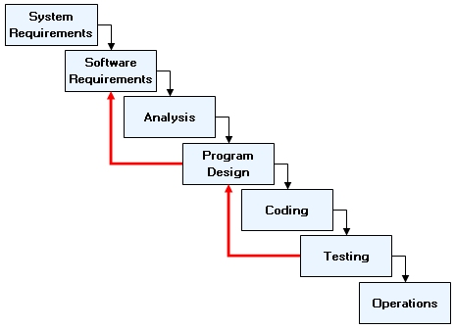

Fig 3.1.1. Development life cycle

**3.2. DATA FLOW DIAGRAMS (DFDs)**

**Level 0 DFD**

Level 0 DFD is the most abstract form of representation. Some important points are:

* Level 0 DFD must balance with the context diagram it describes.
* Input going into a process is different from output leaving the process.

Administrator

Students

HRIS

Faculty members

Fig 3.2.1 Level 0 DFD

**Level 1 DFD**

Next level is level 1 DFD. Some important points are:

* Level 1 DFD must describe must balance with the level 0 it describes.
* Input going into a process is different from output leaving the process.

registered user

employee_login admin_details

student_details login_details

Fig 3.2.2 Level 1 DFD

**Level 2 DFD**

Next level is level 2 DFD. Some important points are:

* Level 2 must balance with the level 1 it describes.
* It is the further decomposition of level 1 DFD.

single_leave multiple_leave

enter password

student_feedback

applications

Fig. 3.2.3 Level 2 DFD (Faculty)

enter password single_leave multiple_leave

Student_feedback

Fig 3.2.4 Level 2 DFD (Administrator)

enter password

Student_feedback

employee_details

Fig 3.2.5 Level 2 DFD (Student)

**3.3. E-R DIAGRAMS**

Admin_details

Student_details

creates

creates

creates

Employee_login

Login_details

Fig 3.3.1 ER Diagram

**3.4. GANTT CHART**

Feb 2 Feb 12 Feb 30 March 10 Apr 5 Apr 20

Code database part

Write the project reports

Integrate and test

Code GUI part

Design GUI part

Design database part

Specification

Fig 3.4.1. Gantt chart

**Chapter 4**

**Experimental results and comparison**

**4.1. HOME SCREEN**

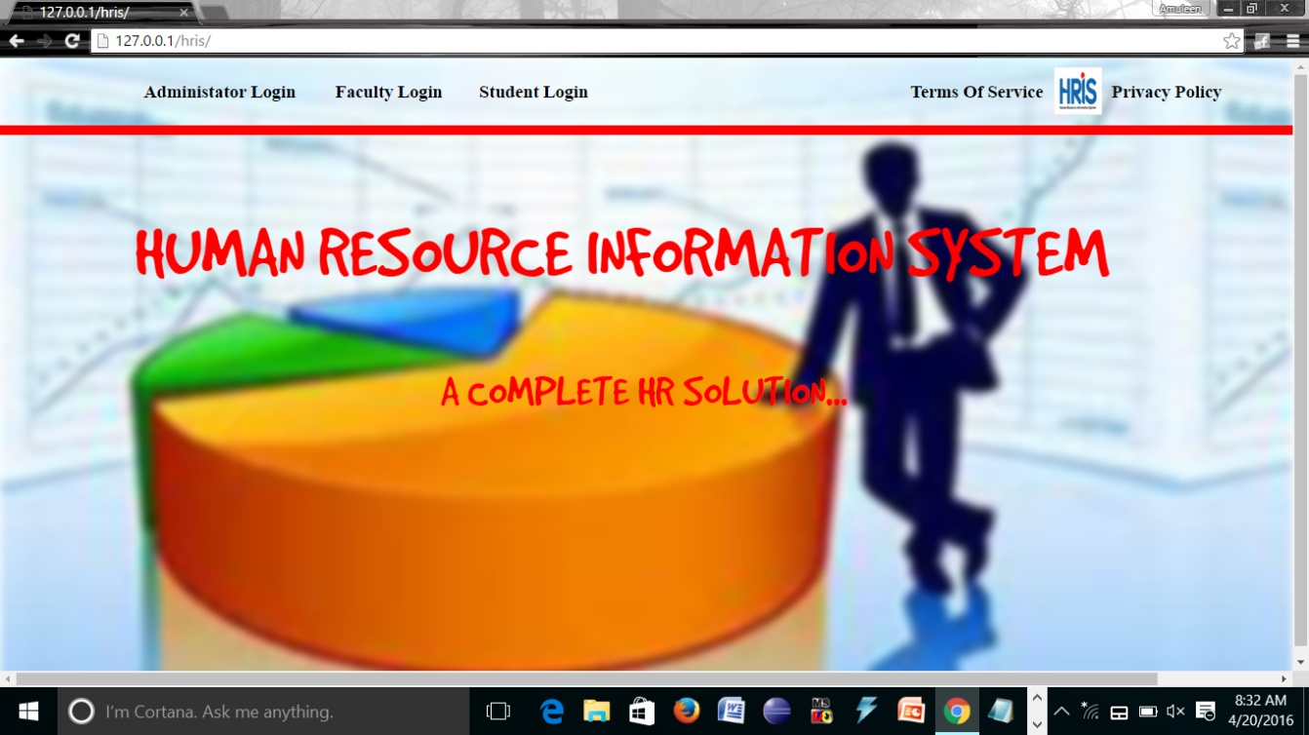

Fig. 4.1. Home screen

This is the front-end user interface of the system. When the user first enters ito the system, he/she is directed to this page. This page has 6 tabs as follows:

* Administrator login: This tab is used by the administrator to log in to their portal.
* Faculty login: This tab is used by the faculty to log in to their portal.
* Student login: This tab is used by the students to log in to their portal.
* Terms of service: This tab directs the user to the page displaying the terms of service of the portal.
* Privacy policy: This tab directs the user to the page displaying the privacy policy of the portal.
* Logo: By clicking on the logo of HRIS, the user is directed back to the home page.

**4.2. LOGIN PAGE**

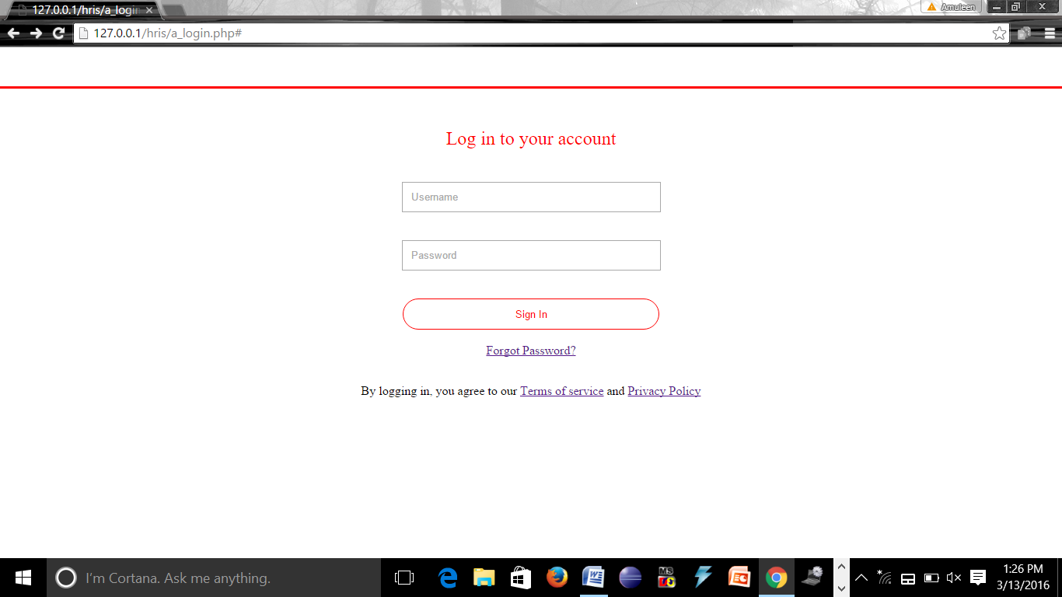

Fig 4.2. Login page

This page lets the users of the system to log in to their respective accounts by entering their username and password in the respective fields provided.

This page has the following tabs:

* Forgot password: By clicking on this link, the users can get their lost/forgotten password in their email account.
* Terms of service: This tab directs the user to the page displaying the terms of service of the portal.
* Privacy policy: This tab directs the user to the page displaying the privacy policy of the portal.

**4.3. ADMINISTRATOR LOGIN**

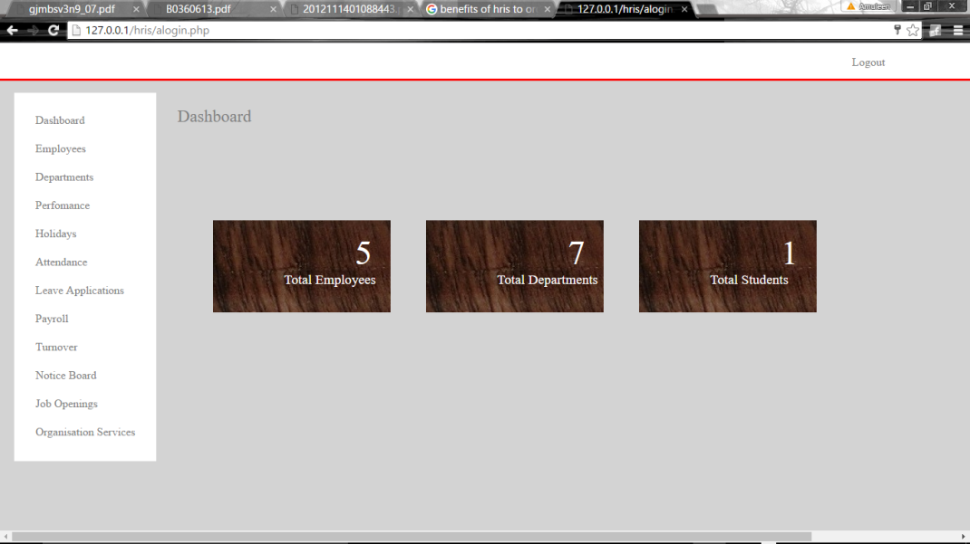

Fig 4.3. Administrator login

This page shows the various features which they can use as follows:

* Employees: By clicking on this tab, the administrator can view the different employees working in the different departments of the college.
* Departments: By clicking on this tab, the administrator can view the different departments in the college.
* Attendance: By clicking on this tab, the admin can track, mark, view and analyze the attendance of the staff I different departments.
* Leave applications: By clicking on this tab, the admin can view and accept/reject the leave applications of the staff.
* Payroll: By clicking on this tab, the admin can view the salaries given to the employees and the bonus and incentives (if any) given to various employees.
* Notice board: By clicking on this tab, the admin can add news and events to be displayed on the notice board to the faculty members.
* Performance: By clicking on this tab, the admin can view and analyze the performance ratings of the staff members by the students.
* Job openings: By clicking on this link, the admin can add job vacancies to be advertised in the various departments within the college.
* Organization services: by clicking on this tab, the admin can view and edit the various services and benefits offered to the staff members by the college.

**4.4. VIEW EMPLOYEES**

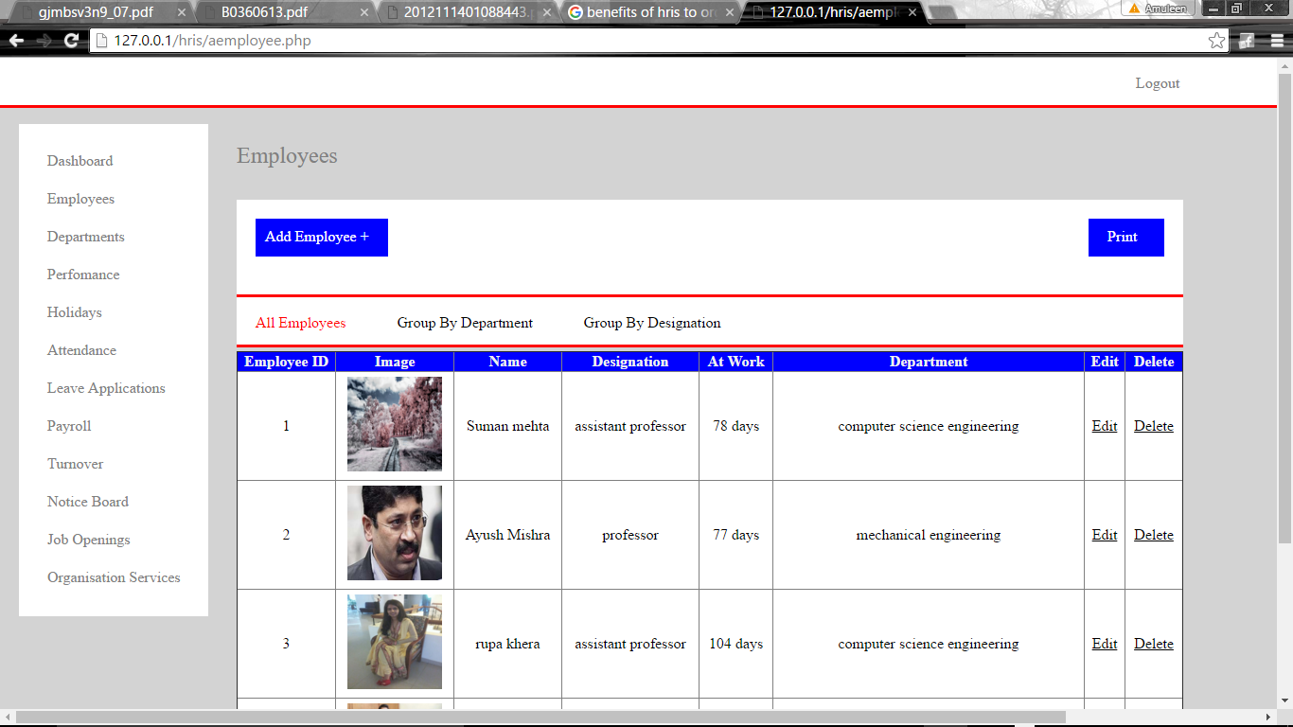

Fig 4.4. View employees

When the admin selects the ‘employees’ tab, the above screen is displayed. It provides the following functionalities:

* Add employee: It allows the admin to add new employee details in the database.
* Print: It allows the admin to print the details of the employees.
* Records: It allows the admin to select the number of records to be displayed.
* Search: It allows the admin to search for specific records.

**4.5. DEPARTMENTS**

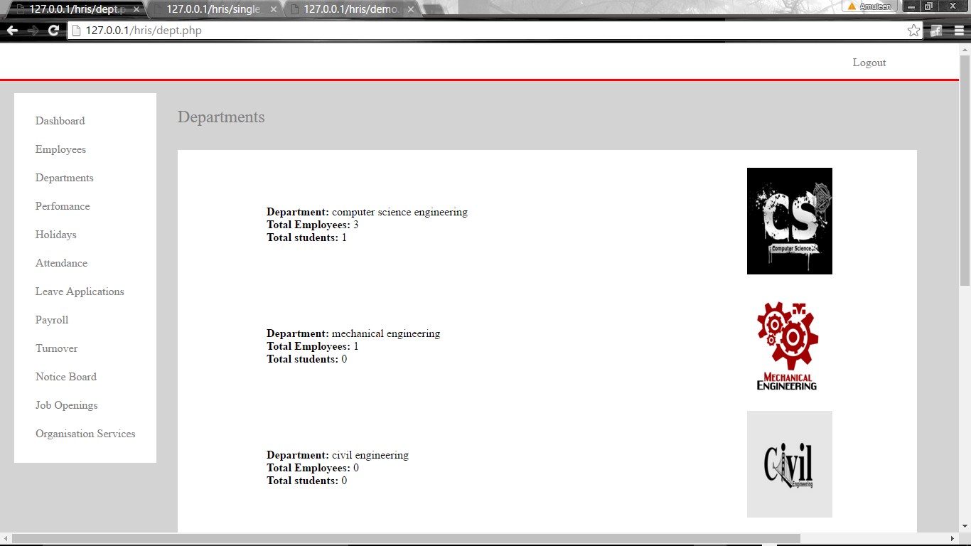

Fig 4.5. Departments

When the administrator selects the ‘department’ tab, h/she is directed to the above page. This page has displays the list of all departments of the college along with the number of students in each department and the number of employees working in each department.

**4.6. PERFORMANCE**

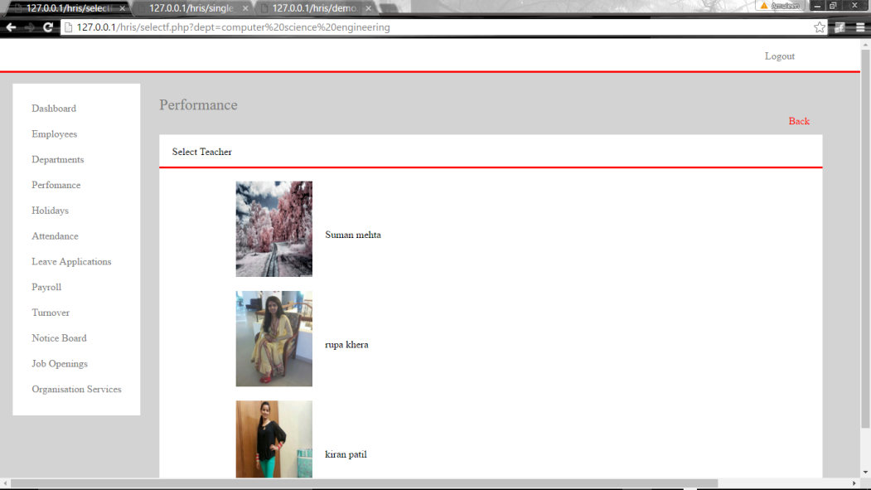

Fig 4.6. Selecting department

Under the performance tab, the above page displays the list of all employees of a particular department for whom you want to view the performance. When one of the employees is selected, the following page is displayed.

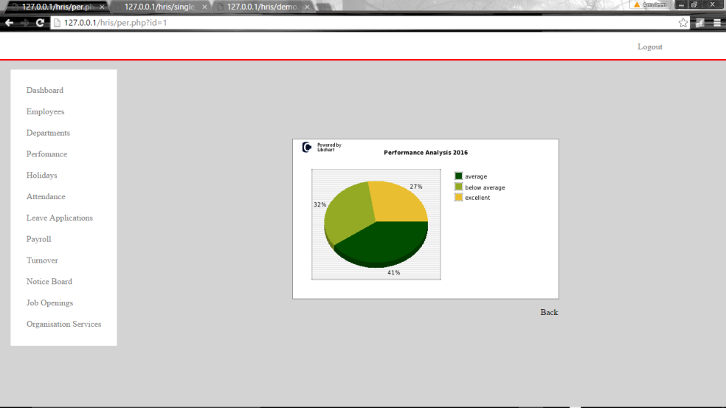

Fig 4.7. View performance

This page displays a pie chart indicating the performance of the selected employee according to the feedback given by the students.

**4.7. HOLIDAYS**

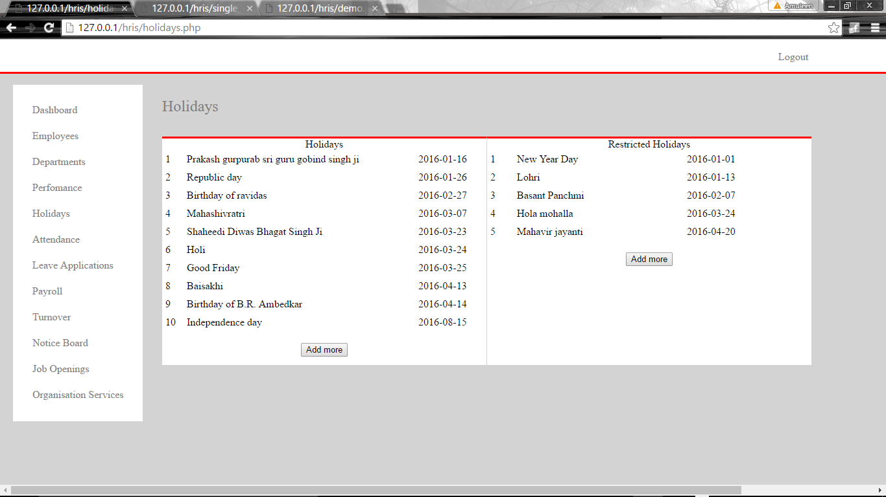

Fig 4.8. Holidays

This page displays all the holidays for the employees. A separate list of ‘Holidays’ and ‘Restricted holidays’ is maintained. The admin has the permission to add more holidays to each of the lists.

**4.8. PAYROLL**

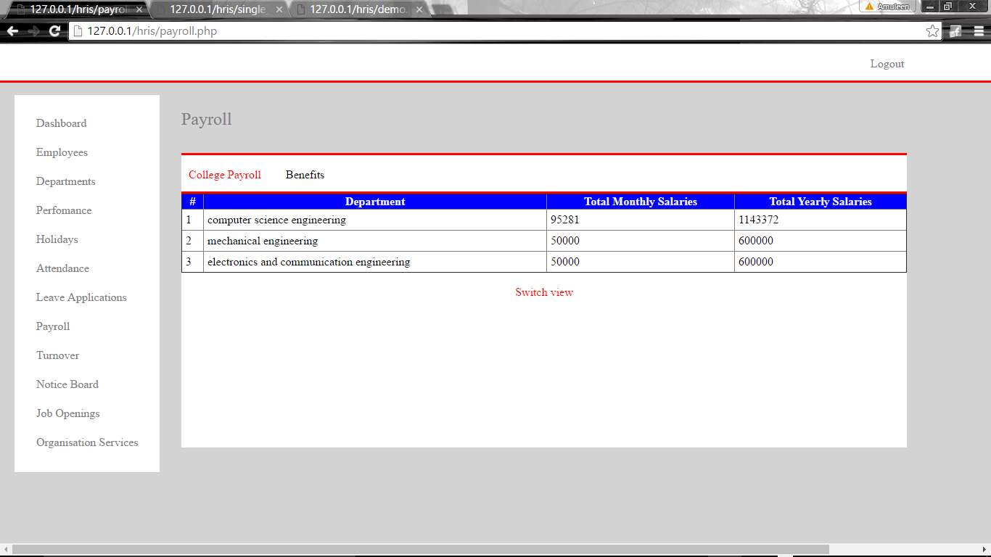

Fig 4.9. Tabular view of payroll

This page displays the total expenses of each department of the college, i.e., the total salary paid by each department to its employees. The admin can also ‘switch view’ to view the details graphically.

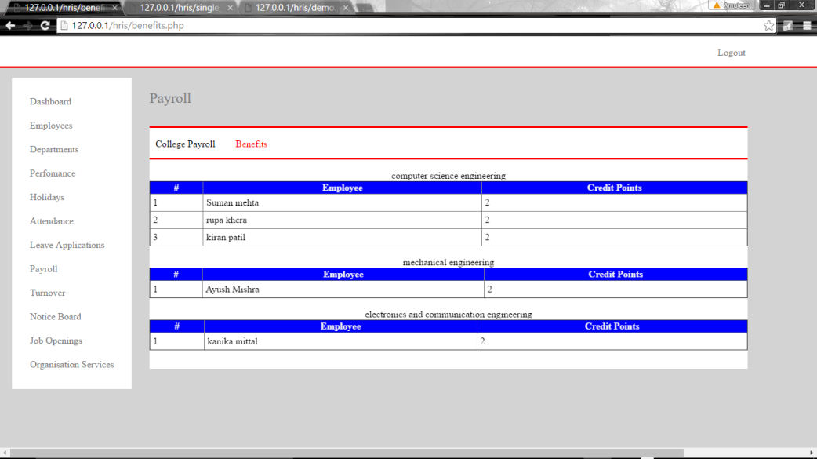

Fig 4.10. Graphical view of payroll

This page shows the credit points of each employee working in different departments. These credit points are used to calculate the benefits provided to the employees.

**4.9. TURNOVER**

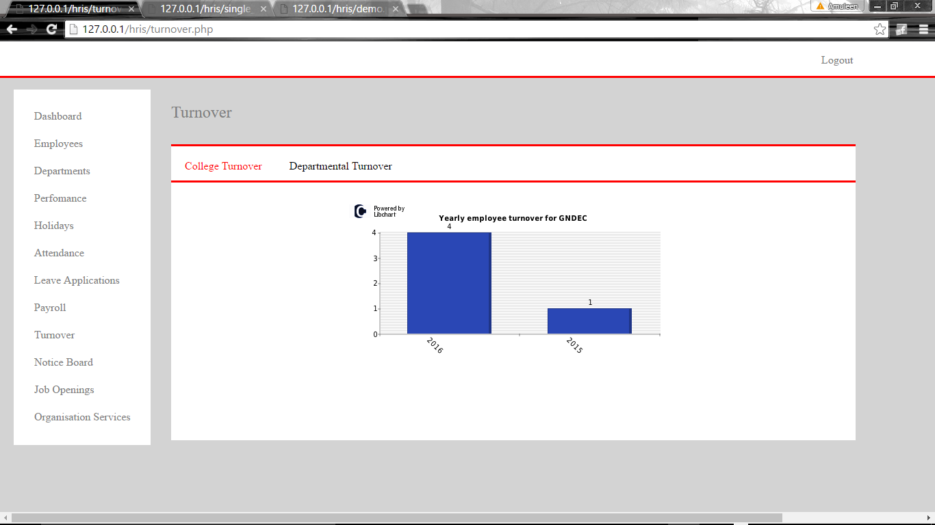

Fig 4.11. Turnover

This page shows the number of employees added to each department during each academic year. This information is displayed in the form of bar graphs to show the overall turnover rate of the college as well as for each individual department.

**4.10. NOTICE BOARD**

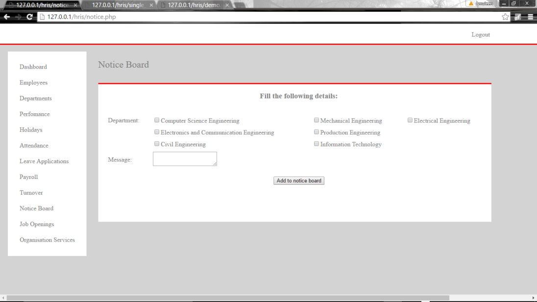

Fig 4.12. Notice Board

This page allows the admin to add some new information to the notice board visible to each employee in their respective portals.

**4.11. ORGANISATION SERVICES**

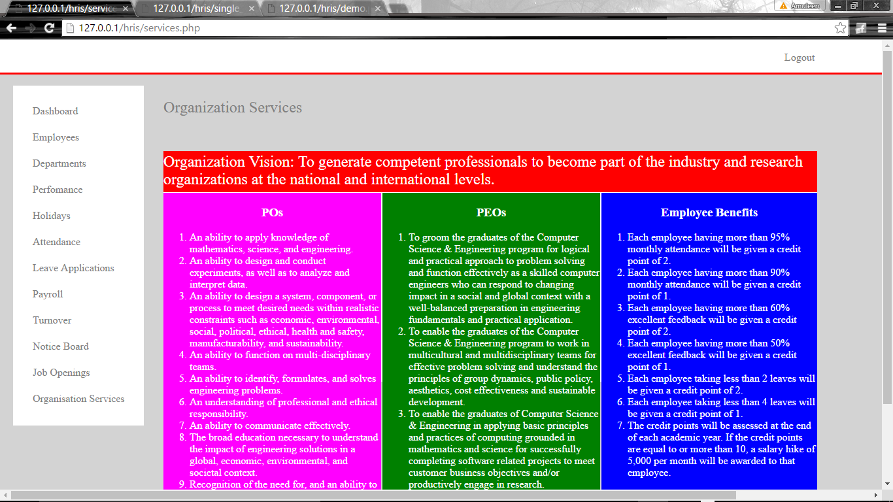

Fig 4.13. Organization services

This page displays the different services offered by the organization: the mission of the organization, the PO’s of different departments, the PEOs and the benefits to be provided to the employees.

**4.12. ATTENDANCE**

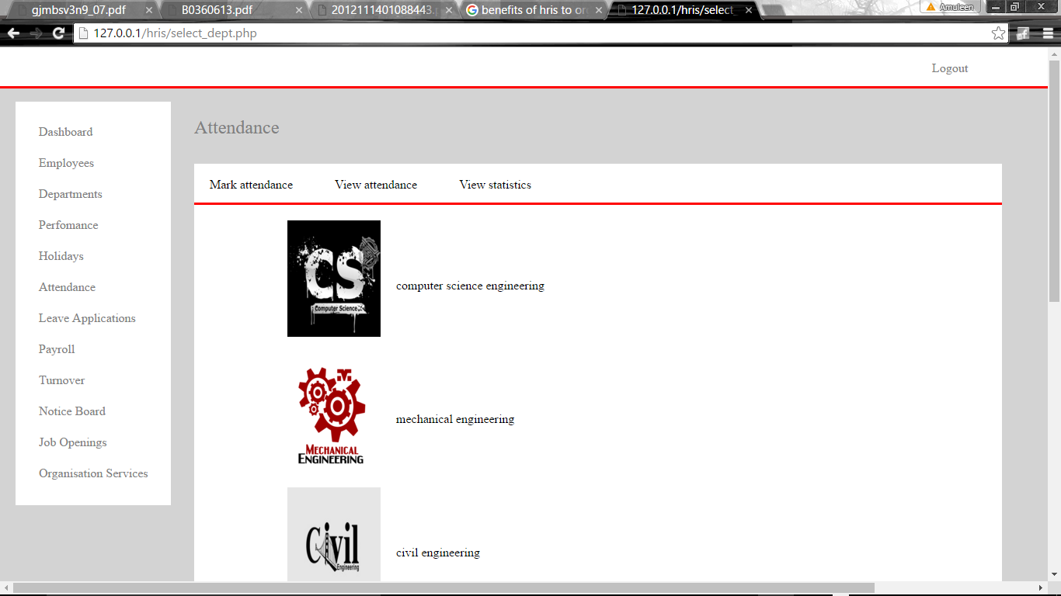

Fig 4.14. Attendance

When the admin select the attendance feature, this page is displayed. It has the following functions:

* Mark attendance: It lets the admin mark the attendance for employees of different departments.
* View statistics: It lets the admin to view the attendance analysis of the different departments on a daily, monthly and yearly basis.
* View attendance: It lets the admin view the daily attendance of various employees of different departments.

**4.13. LEAVE APPLICATIONS**

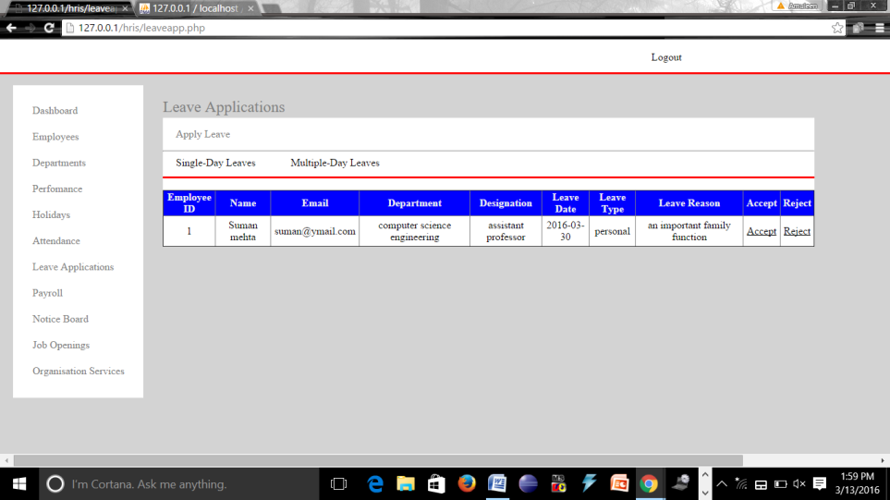

Fig 4.15. Leave application

When the admin selects leave application tab, the above screen is displayed. The screen allows the admin to view various single and multiple leave applications and allows him to accept or reject the application which will be notified to the recipient of the application in his/her respective portal.

**4.14. JOB OPENINGS**

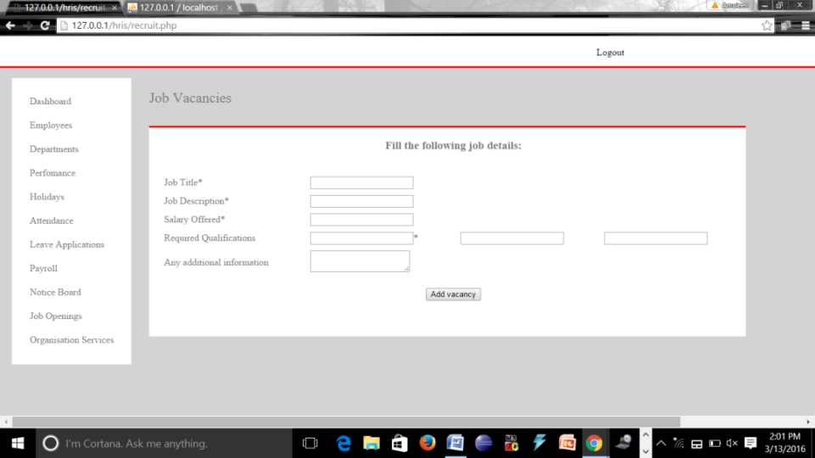

Fig 4.16. Job openings

When the admin selects the job openings tab, the above screen is displayed which lets the admin fill the information regarding the job vacancies in different departments to be advertised within the college.

**4.15. ATTENDANCE STATISTICS**

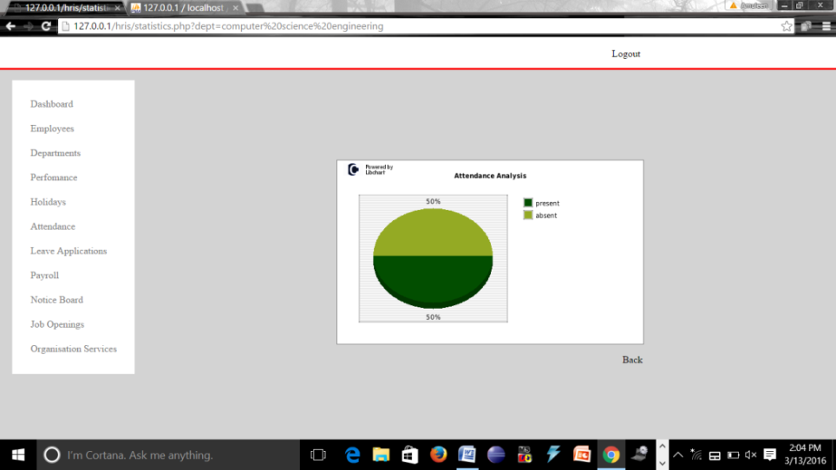

Fig 4.17. Attendance statistics

The system allows the admin to view the pie charts depicting the attendance analysis of the various employees.

**4.16. FACULTY LOGIN**

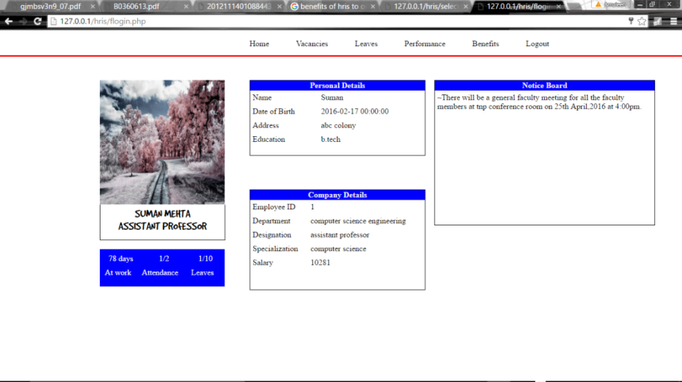

Fig 4.18. Faculty login

This page consists of the following sections:

* Information regarding the employee including his/her attendance, days of work and leaves.
* The personal details of the employee.
* The departmental details of the employee.
* A notice board displaying the notices generated by admin.

**4.17. FACULTY LOGIN: VACANCIES**

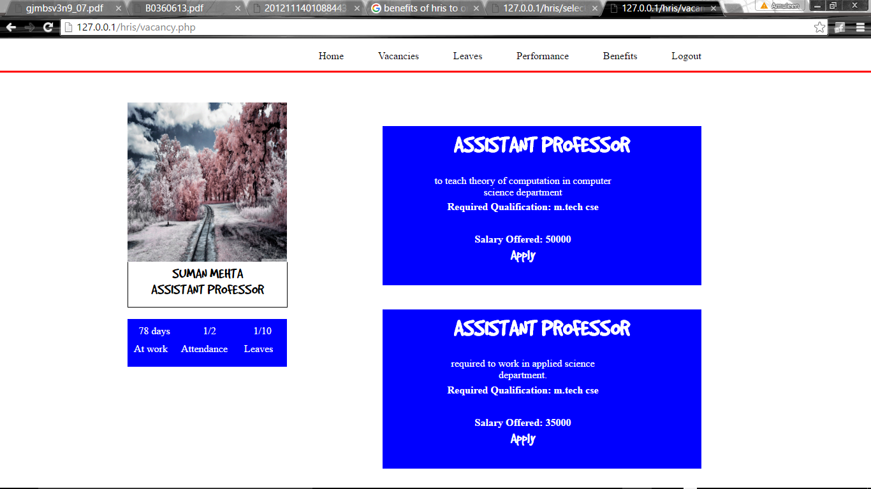

Fig 4.19. Faculty Login Vacancies

The faculty members can log in to their portals to view the various vacancies within the college and apply for the same by uploading their resumes and other details.

**4.18. FACULTY LOGIN: LEAVES**

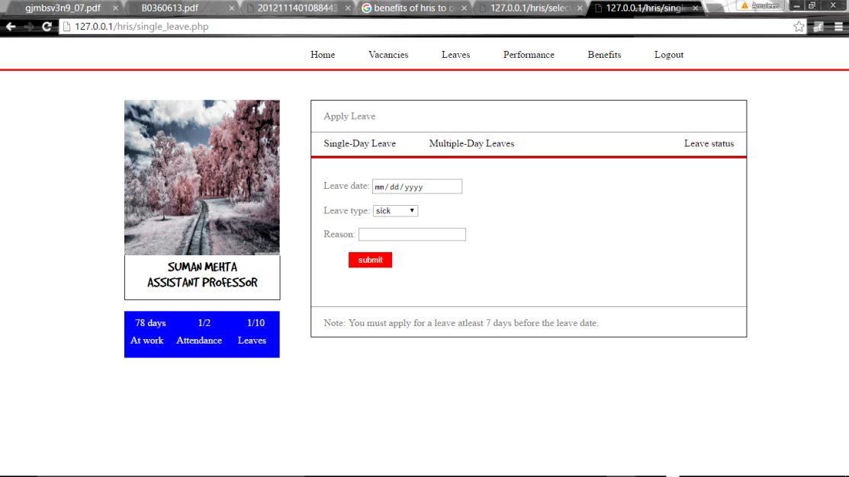

Fig 4.20. Faculty login leaves

The faculty members can apply for leaves by clicking on the leave tab which lets them apply for single-day leaves, multiple-day leave and also view the leave notifications i.e. whether their leave application has been accepted or rejected.

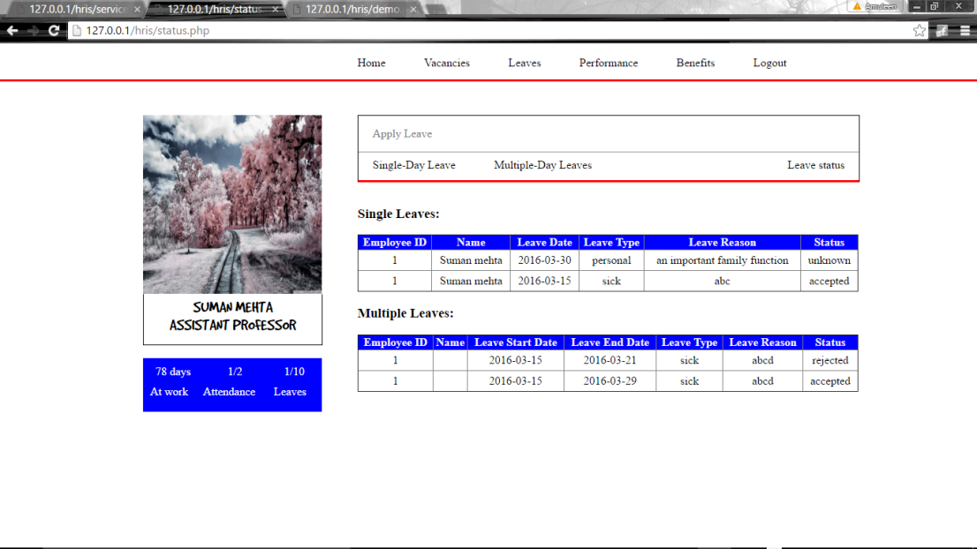

Fig 4.21. Notification view

The above page displays the leave notifications to the employees to indicate whether their leave has been accepted or rejected by the admin.

**4.19. PERFORMANCE**

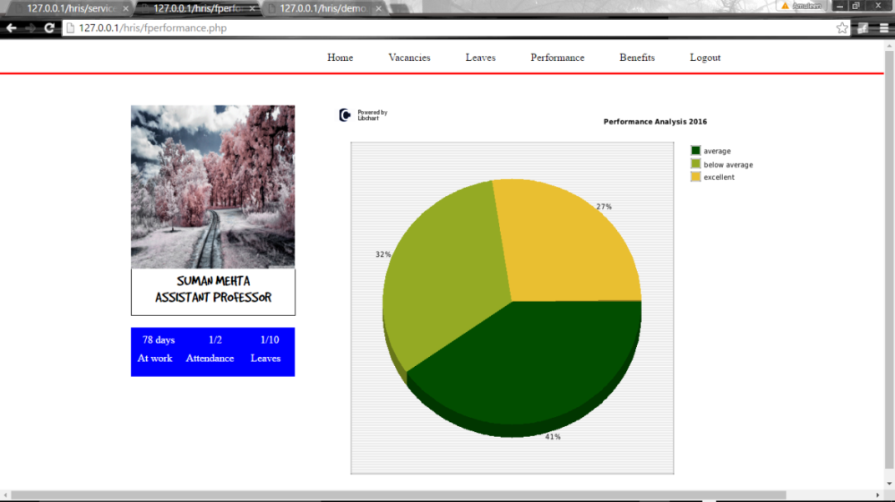

Fig 4.22. Faculty performance

This page displays the performance of the employee to him/her in the form of graphical charts.

**4.20. BENEFITS**

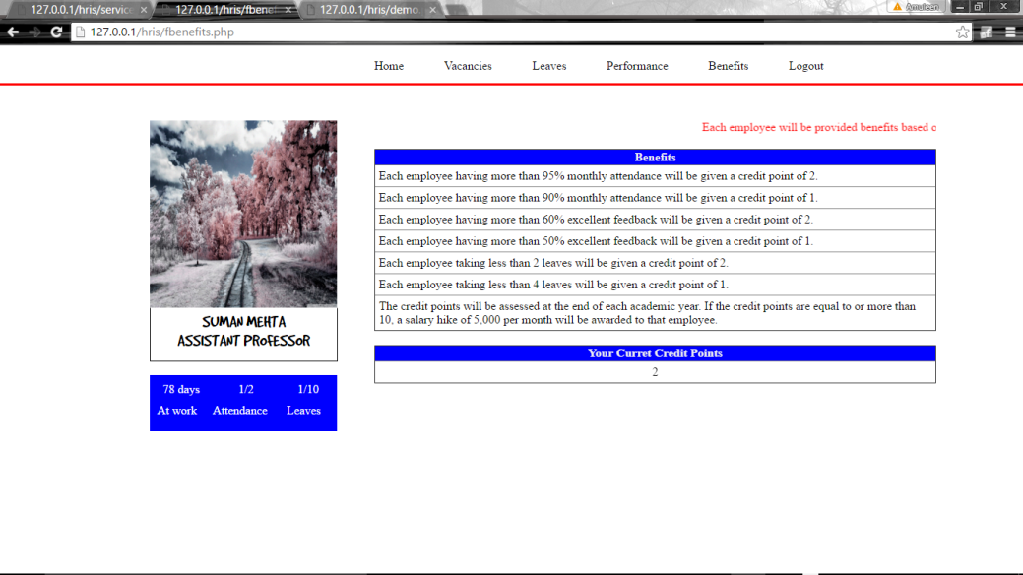

Fig 4.23. Benefits

This page displays the various benefits offered to the employees by the college and the conditions that need to be followed by the employees to claim these benefits.

Also, the current credit points of the employee are displayed.

**4.21. STUDENT LOGIN: FEEDBACK**

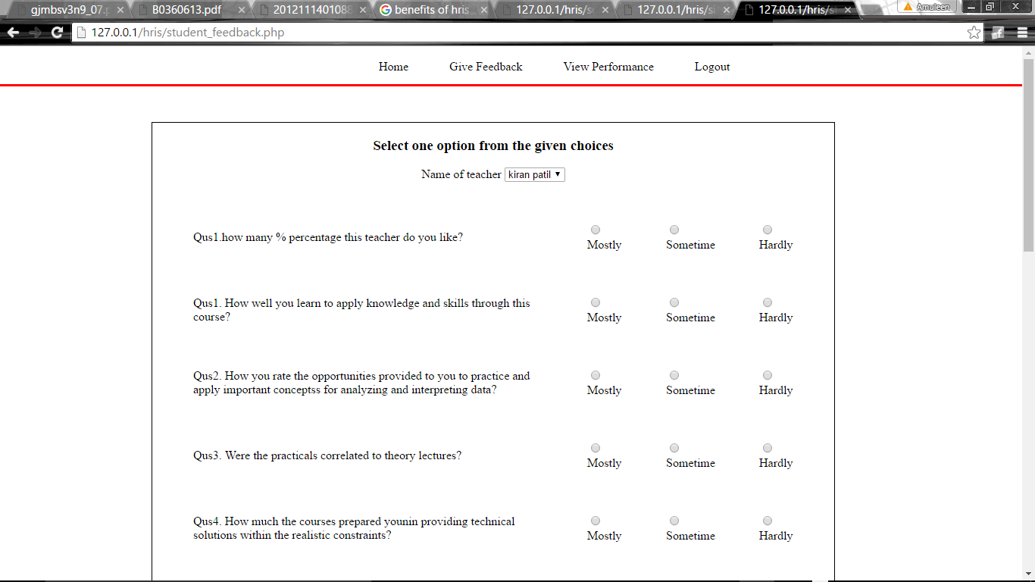

Fig 4.24. Student feedback

When the students log in to their portals, they can give feedback to various teachers by clicking on the ‘Give feedback’ tab and then filling out the questionnaire that follows.

**4.22. STUDENT LOGIN: VIEW PERFORMANCE**

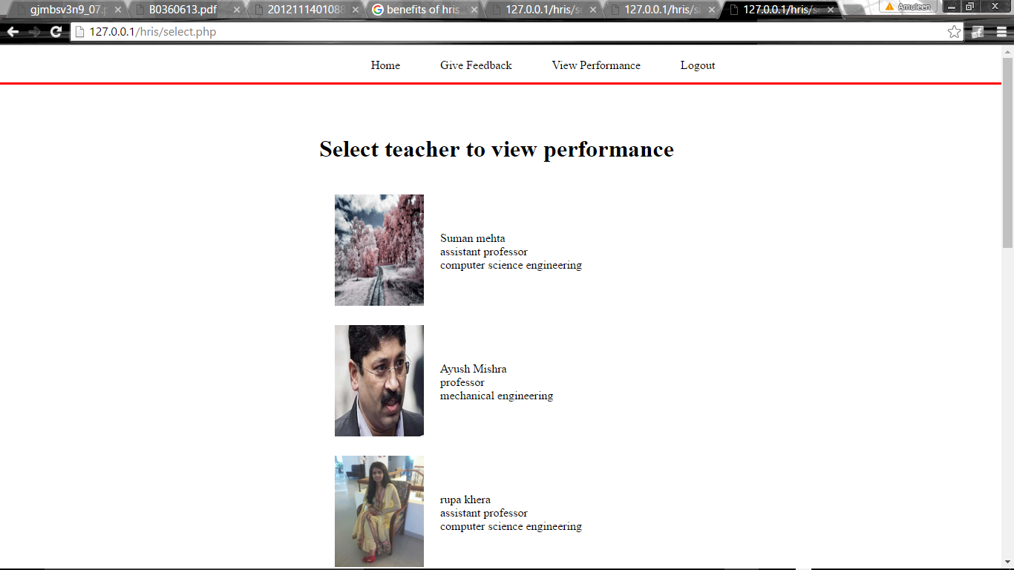

Fig 4.25. Student performance view

The students can view the performance of various teachers by clicking on ‘view performance’ tab and then selecting the name of the teacher to view his/her performance.

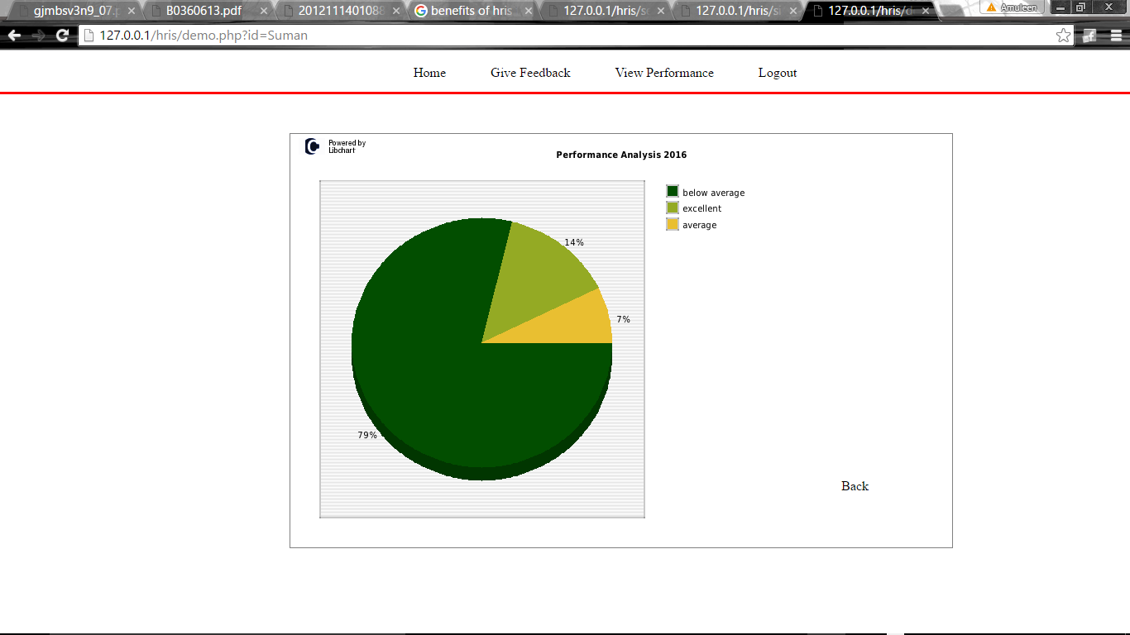

Fig 4.26. Performance pie chart

The above page shows the performance of the selected teacher in the form of a pie-chart.

**4.23. DATABASE**

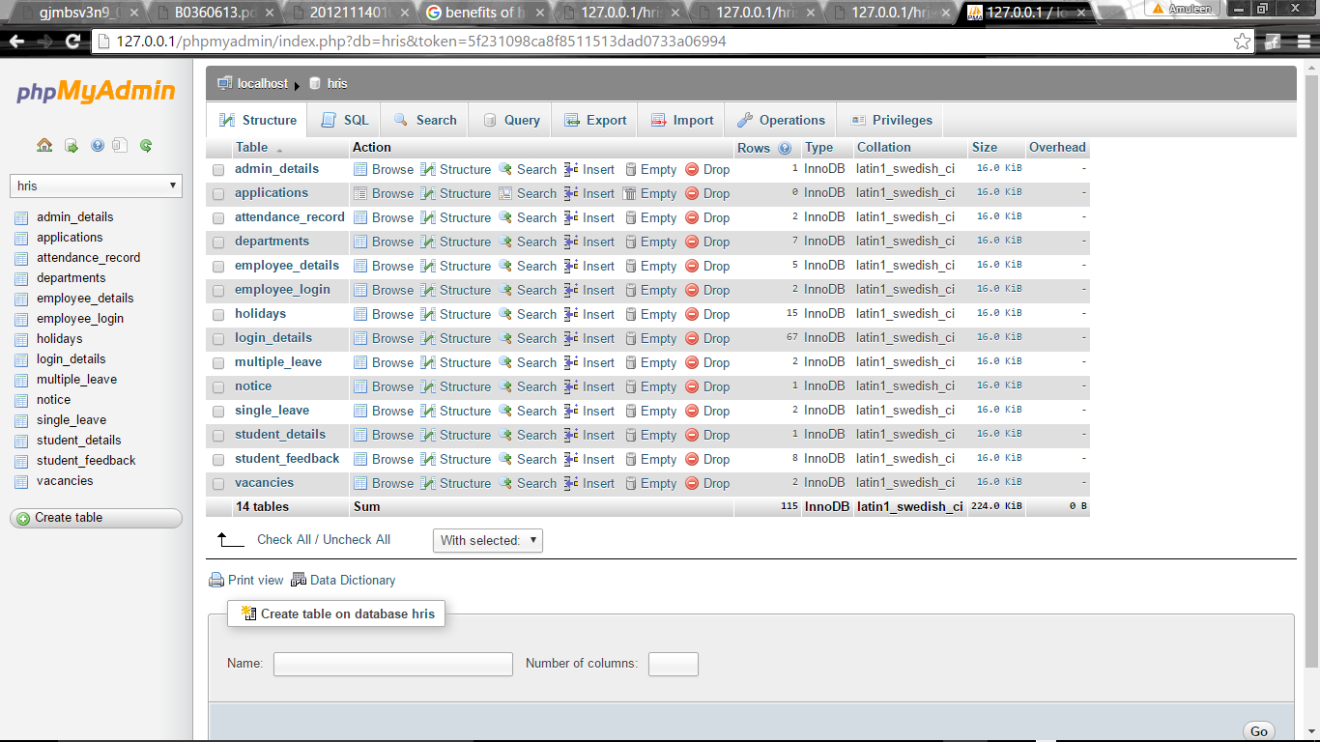

Fig 4.27. Database view

The above screen shows the database tables that have been created to support the operation of the software.

**COMPARISON**

Table 4.1. Comparison

|  |  |  |  |
| --- | --- | --- | --- |
| S.NO. | PARAMETER | TRADITIONAL SYSTEM | HRIS |
| 1. | Accuracy | The results derived using the traditional system are not guaranteed to be 100% accurate due to the presence of noise, unavailability of some information or internal bias. | The results derived using HRIS are guaranteed to be accurate as the results are based on objective parameters and are derived automatically by the system. |
| 2. | Automation | The traditional system of human resource management has no automation and hence every task and deductions need to be done manually. | The HRIS provides a way to fully automate the process of management of the human resources as all the information is stored at one place and can be manipulated by the system in several ways to provide the desired information in the desired format. |
| 3. | User-friendliness | The traditional system does not have 100% user-friendliness because people working on the task may not be fully aware of the work environment. | HRIS depicts a high level of user-friendliness as the people need to be trained only once on the easy-to-use interface. |
| 4. | Availability | The traditional system does not guarantee the availability of the desired information in the desired format at the desired time. | HRIS guarantees the availability of any information you need in the desired format at the desired time just by the click of a button. |

**Chapter 5**

**Conclusion, Summary and Future scope**

**5.1. CONCLUSION**

**Aim:** The aim of this project was to develop and deploy a complete human resource solution for managing the faculty of the college in a systemized and objective manner in lesser time and with improved accuracy.

**Conclusion:** This project has been successfully created to achieve all of its desired goals. This project has been tested on the following parameters:

Table 5.1. Conclusion

|  |  |  |
| --- | --- | --- |
| **S.NO.** | **PARAMETER** | **OUTCOME** |
| 1. | Easy-to-use user-friendly interface | Positive |
| 2. | No expensive hardware or software required for project deployment. | Positive |
| 3. | Effective results in lesser time. | Positive |
| 4. | All in one HR solution. | Positive |
| 5. | Guaranteed result accuracy. | Positive |

**5.2. SUMMARY**

Human resources information systems (HRIS) can play an important part in a company’s HR function. After all, we live, work and play in the information age. Implementing an effective HRIS can be sure-fire for HR to stay on the cutting edge in its bid to deliver more effective and streamlined service. The main conclusion of this paper is the realization that the use of computerized HRIS is most effective then manual because its help to maintain data with more accuracy in less time. And that it also true that HRIS functions improve HRM in terms of administrative purposes and analytical purposes. HRIS work as a key component of the organization and a good HRIS will provide important information about human resources needs and capabilities; this information will assist the management team in establishing the organizational mission and setting goals and objectives in motion. HRIS is not limited to the computer hardware and software applications that comprise the technical part of the system: it also includes the people, policies, procedures and data required to manage the HR function.

**5.3. LIMITATIONS**

1. The foremost limitation is on the subject of the industry perspective. HRIS role can be studied in any of the sector as human resources are assets of the organizations irrespective of the sector. Future research efforts could be focused into exploring the differences between traditional methods of HRM and HRIS.

2. Other limitation is the static nature of the study, that is, the study is based on the existing scenario of the level and usage of HRIS in Service Based Organizations; but HRIS can be enhanced in future.

3. Other limitation is that the questionnaire survey may endure with the reaction bias, although this is a cost effective and reliable to some extent but not totally reliable. Therefore, field observations and qualitative interviews of managers or concerned persons from the sample are also anticipated.

**5.4. FUTURE SCOPE:**

* Based upon the reactions of the users and the effectiveness of deployment, the project can be further enhanced by adding the ‘training’ function to enhance the available skill set within the organization.
* An android application may also be developed for the system in future to additionally enhance the ease of use.

**References**

* <http://www.google.com>
* <http://www.wikipedia.org>
* <http://w3schools.com>
* <http://stackoverflow.com>
* <http://snaphrm.org>
* <http://www.ehow.com/facts_5785832_definition-human-resource-information-system.html>
* Kirstie S. Ball, (2001),"The use of human resource information systems: a survey", Personnel Review, Vol. 30 Issue 6, pp. 677 – 693.
* Martinsons, M. G. (1997), “Human resource management application of knowledge based systems”, International Journal of Information Management, Vol. 17, pp 35-53.
* Human Resource Management System. (2012). Retrieved April, 2012, from <http://en.wikipedia.org/wiki/>
* John, E. (2008). Make sure that HR gets a seat at the ERP planning table. Retrieved from http://www.hrworld.com/features/erpplanning-table-070208/
* Our Guide: Ms. Blossom